Shop by Manufacturer Custom Module for Magento



Table Of Contents

Table of Contents

Table Of Contents 2

1. Introduction 3

*2.* Overview 3

3. Requirements 3

4. Features 4

4.1 Features accessible from Front End 4

4.2 Features accessible from Back End 4

5. Installation 5

5.1 Implementation 5

5.2 Manual Installation 5

6. Configuration 6

6.1 Admin Configuration 6

6.2 Manufacturer Setting 6

6.2.1 Enabling the Module 6

6.2.2 Creating Attribute 7

6.3 Manufacturer Manager 11

6.3.1 Manage Manufacturer 11

6.3.1 Add Manufacturer 12

6.4 Assigning Products to Manufacturer 13

6.5 Frontend Configuration 14

6.5.1 Placing Shop by Manufacturer where required. 14

7. Technical Information 17

8. Un-installation 17

9. Unsupported Features & Known Issues 18

10. Troubleshooting 18

# Introduction

This document is intended as a technical resource for the installation, setup and use of the “Shop By Manufacturer” Custom module for Magento.

The extension is Plug& Play and compatible with Magento Enterprise version 1.10, 1.11, 1.12, 1.13 and community version 1.6 &1.7

# Overview

Magento is an open source e-commerce CMS that uses a LAMP (Linux, Apache, MySQL, PHP) architecture.

As an open source platform, the modifications one could make to their website are limitless. With this in mind the integration was developed to incorporate as close to core Magento API functionality as possible.

Shop by Manufacturer Extension is developed primarily for the people who trust some brands and want to buy products of that brand only. This extension allows you to create new brands and connect products to those brands.

The extension generates a landing page with all created brands. Clicking on any brand link takes you to that specific brand landing page.

# Requirements

1. Magento Enterprise Edition v1.10 and above or Magento Community Edition v1.6 and Above
2. Magento*Shop By Manufacturer* Module from Magento Connect
3. Magento Administrative Privileges.

# Features

This is a Third Party Module to integrate with Magenta, features have been documented below:

## Features accessible from Front End

1. **Display brand image (logo) in the frontend**  
   you can display selected brands on home page. While clicking on any brand logo, you will be redirected to Shop by Manufacturer listing page.
2. **Call Shop By Manufacturer block anywhere**

You can call this block on Home page and from there you can navigate to brands listing page.

1. **Allows to feature certain brands**

You can feature some brands and show only featured brands on home page. You can enable/disable brands to be shown on home page.

1. **Automatically creates a landing page with all brands created**

A landing page will automatically be created for every brand created through admin

## Features accessible from Back End

1. **Creating Brands**

You can add, edit, delete, enable/disable brands.

1. **Priority of Brands**

You can assign priority to every brand, so the most important ones will be displayed first. If the priority is not set up, brands will be sorted in the order in which they are crated.

1. **Assign products to brands**

You can assign products to every brand. Only those products will appear in brands detail page.

1. **Multi-store support**

You can specify stores where brands are visible.

# Installation

## Implementation

Steps to Install This Module

1. Install the Shop By Manufacturer Module from Magento Connect
2. After the installation is complete, browse to your Magento homepage in order to complete the module install
3. You should now have a “General” and “Frontend” section in your Admin Panel under System>Configuration>Manufacturer

**Further details are given in the configuration section**

## Manual Installation

1. Obtain a copy of the Shop by Manufacturer Module
2. Unzip the Module files into a local directory.
3. Move all files into their respective directories in your Magento installation directory on the FTP server as they appear after unzipping the package.
4. Clear your store cache.
5. In your Magento admin panel, this is under System > Cache Management.
6. Log Out of your Magento Admin and then log back in.
7. This refreshes the Magento ACL date which effects your administrative permissions. You will not see expected module behavior until you do this. You may also need to refresh your cache.
8. After all copying is complete browse to your Magento homepage in order to complete the module install
9. You should now have a “General” and “Frontend” section in your Admin Panel under System>Configurations>Manufacturer

**Further details are given in the configuration section**

# Configuration

## Admin Configuration

All configurations are handled in the MagentoAdmin Panel. The Configuration is located in **Admin Panel**🡪**Zeon Extensions**

[Refer Figure 6-1]

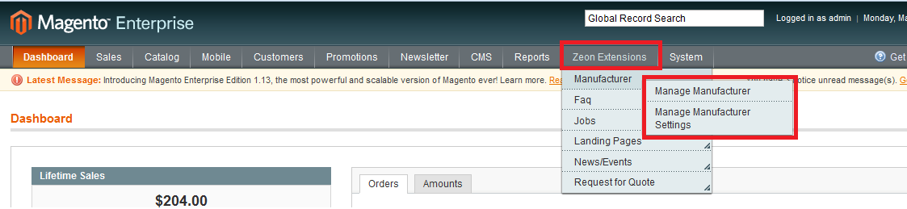

Figure ‑

## Manufacturer Setting

### Enabling the Module

Login to admin panel and navigate to Zeon Extensions ->Manufacturer-> Manage Manufacturer Settings

* **General**

Enable the Extension by selecting Enabled field to Yes[Refer Figure 6-2]

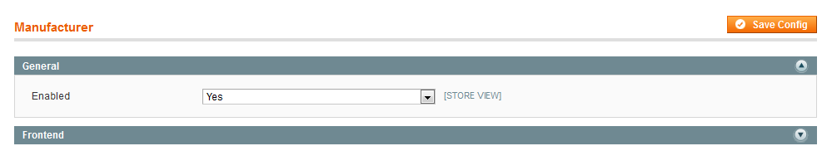

Figure ‑

* **Frontend**

Enter ‘Manufacturers Attribute Code’. This is going to be your attribute for brands.

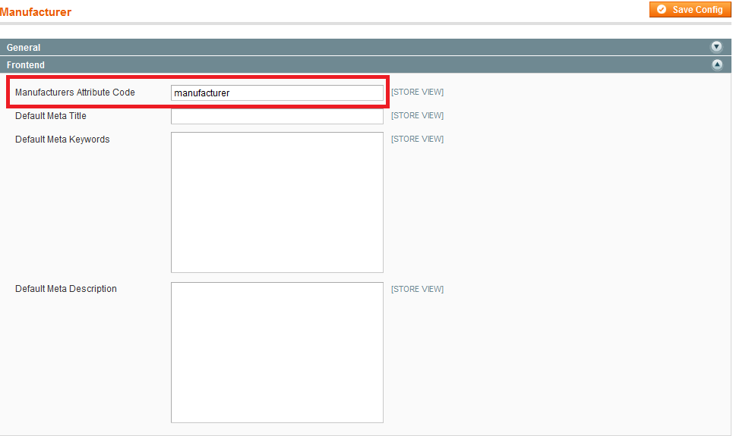

Figure ‑

### Creating Attribute

Go to Catalog->Manage Attributes[Refer Figure 6-4]

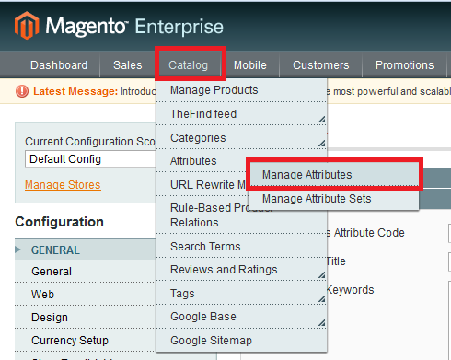

Figure ‑

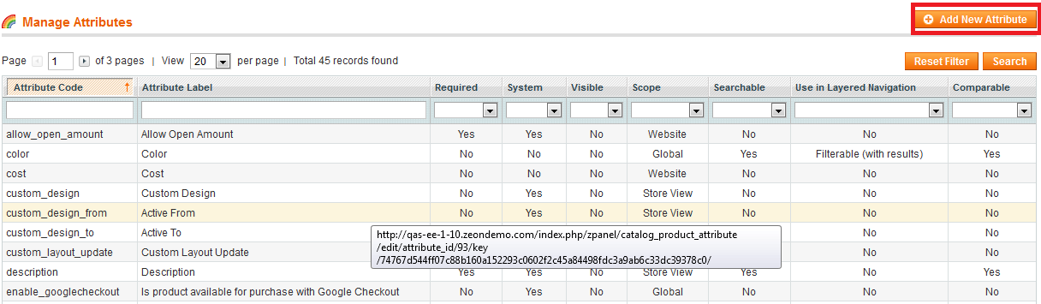

Figure ‑

Then click on ‘Add New Attribute’ and then create an attribute called ‘manufacturer’ (The attribute code should be same as what you entered in ‘Manufacturers Attribute Code’).

We had entered manufacturer there. So we will create an attribute with the attribute code as ‘manufacturer’

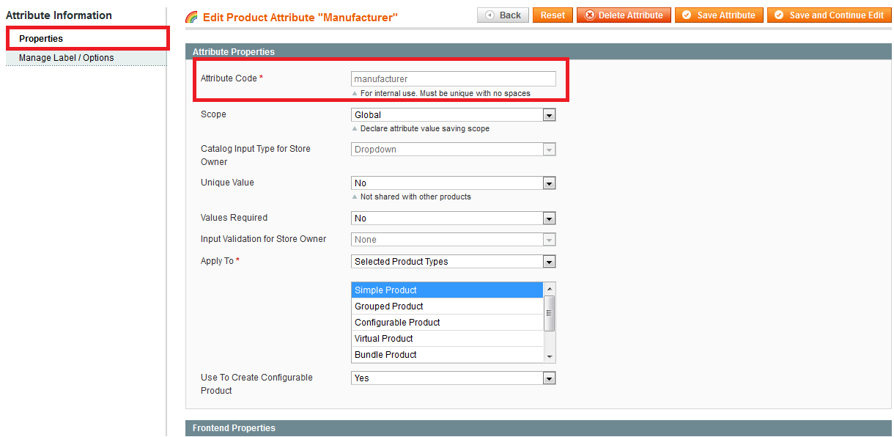

Figure ‑

As you can see in the above figure attribute code is **manufacturer**. Its scope should be kept **Global**. And catalog input type for store owner should be **Dropdown**.

[Refer Figure 6-7]

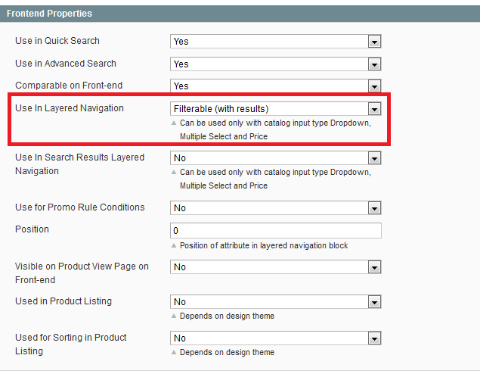

Figure ‑

In the next tab, Use in Layered Navigation should be selected as ‘Filterable (with results)’

Then select next tab i.e. ‘Manage Label/Options’. In the options enter all the brands names that you want to create.

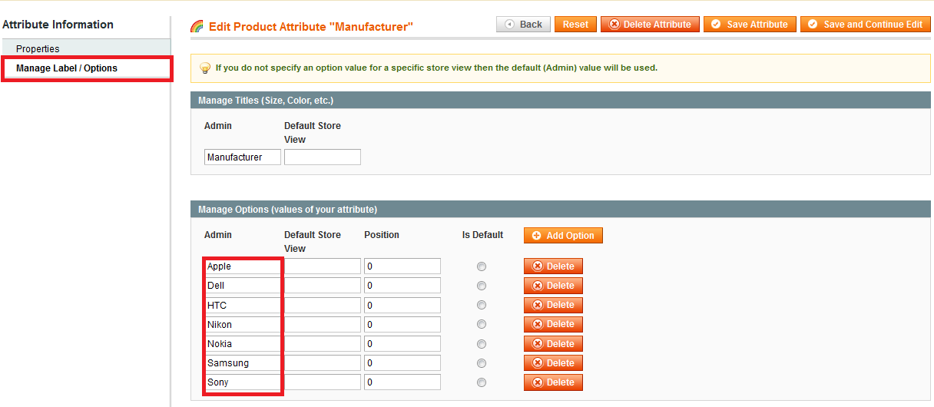

Figure ‑

Save the attribute. Then go to Catalog->Manage Attribute Sets.

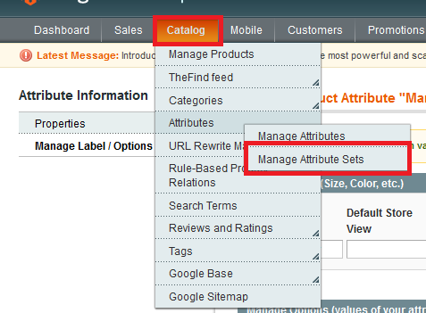

Figure ‑

Select the Attribute Set. In our case we have ‘Default’ as our attribute set.

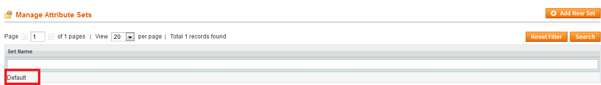

Figure ‑

Click on your attribute set and then drag your created attribute in your attribute set.

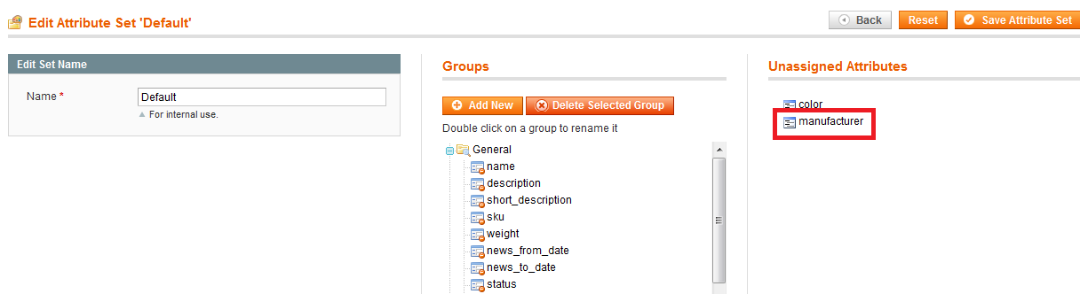

Figure ‑

We had created ‘manufacturer’ attribute. Now we will drag this attribute in our attribute set. So that it becomes visible while creating any product in default attribute set.

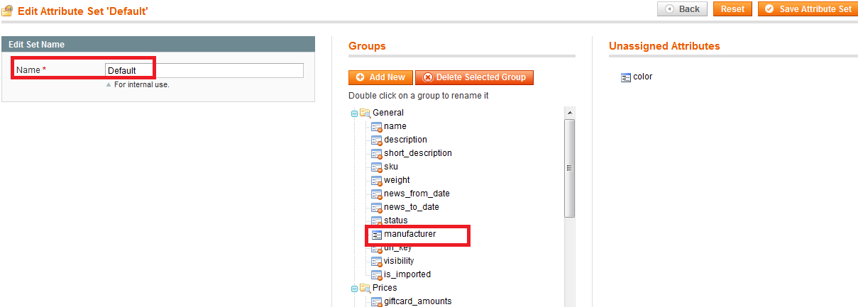

Figure ‑

Save the Attribute set. Then go to Zeon Extensions->Manufacturer->Manage Manufacturer.

## Manufacturer Manager

### Manage Manufacturer

Navigate to Zeon Extensions->Manufacturer->Manage Manufacturer

Shows ID, Manufacturer Title, Updated Time, Status and a link to Edit the Manufacturer Change Status or delete by selecting from the grid and selecting the action

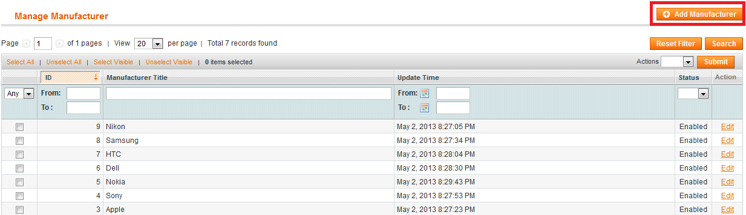

Figure ‑

### Add Manufacturer

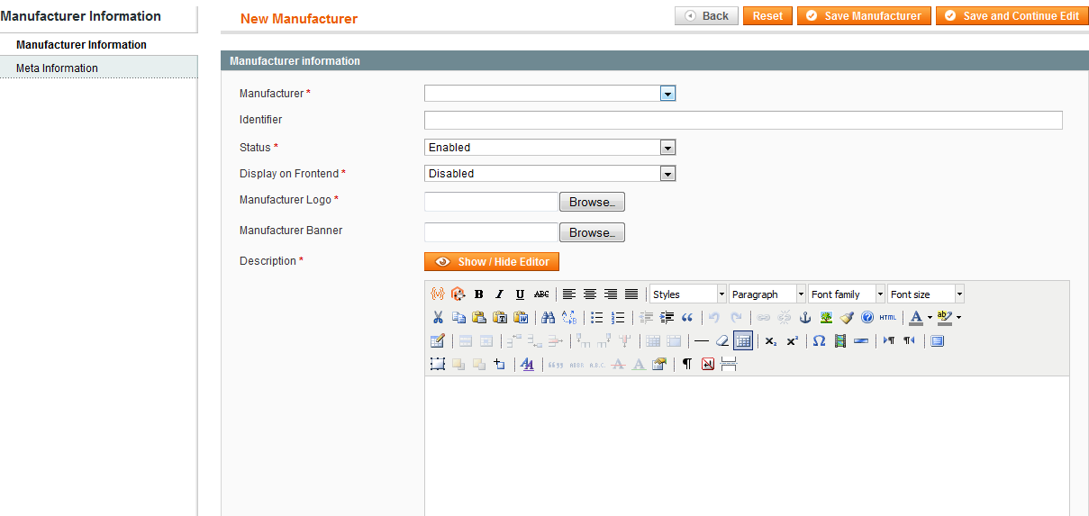

Figure ‑

* **Manufacturer**: Shows the list of all the manufacturers. (These are the option values that you entered while creating manufacturer attribute). Select the manufacturer that you want to create from the dropdown.
* **Identifier**: It is the unique value for a manufacturer.
* **Status**: Select Enabled if you want to enable that manufacturer and select disabled if you do not want that manufacturer to appear on frontend.
* **Display on Frontend**: Select Enabled if you want that manufacturer to appear on Home Page and select disabled if you do want that manufacturer to appear on Home Page.
* **Manufacturer Logo**: Upload the logo for that manufacturer.
* **Manufacturer Banner**: Upload the banner for that manufacturer (It is optional).
* **Description**: Description about that Manufacturer.

## Assigning Products to Manufacturer

Navigate to Catalog->Manage Products

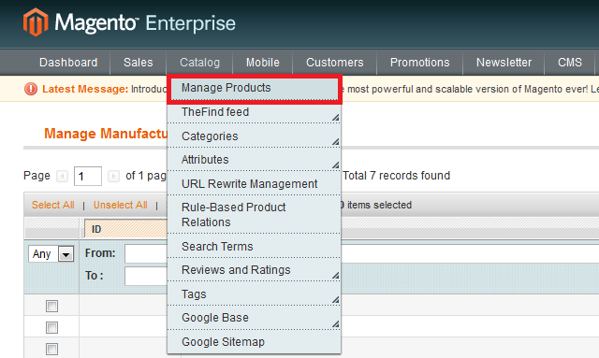

Figure ‑

Edit the Product or create new Product. In the Manufacturer option select the manufacturer in which you want your product to be assigned.

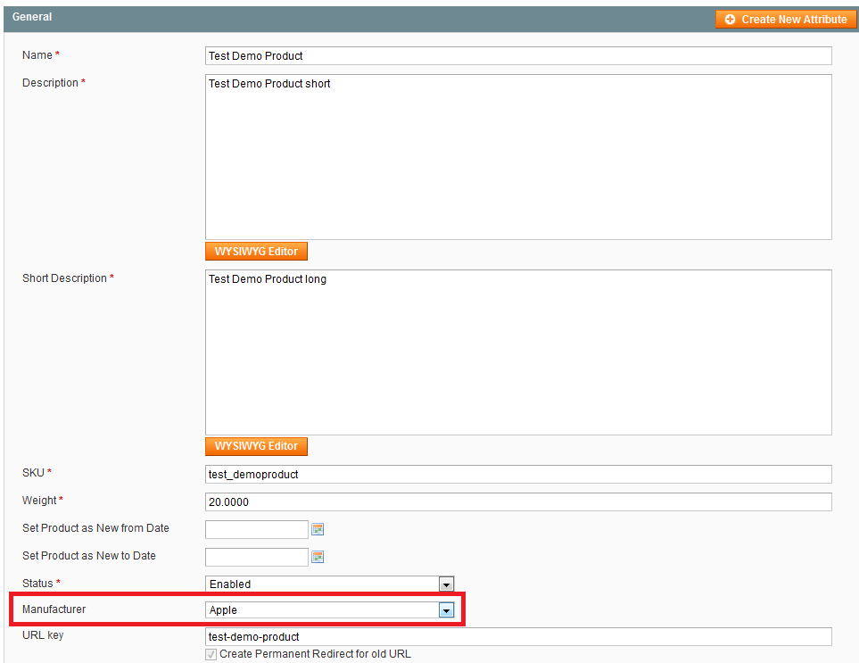

Figure ‑

Do this for all the products and assign the products to the respective manufacturer.

## Frontend Configuration

As soon as you install the extension, you will see Shop by Manufacturer block in your content area.

### Placing Shop by Manufacturer where required.

If you want to change the position of that block then go to

**/app/design/frontend/base/default/layout/zeon/manufacturer.xml**

In manufacturer.xml, you will find following lines of code

<cms_index_index>

<reference name="content">

<block type="zeon_manufacturer/home" name="home_manufacturers_list">

<action method="setTemplate" ifconfig="zeon_manufacturer/general/is_enabled">

<template>zeon/manufacturer/home.phtml</template>

</action>

</block>

</reference>

</cms_index_index>

Remove this code from manufacturer.xml

**To display Shop by manufacturer block on your home page at any other place, you can add following lines of code in your CMS Home Page Content Section. Add this code in whichever div you want your block to be displayed.**

{{block type="zeon_manufacturer/home" attribute_code="manufacturer" random="1" limit=“4“ template="zeon/manufacturer/home.phtml}}

**OR**

**If you want to call it through layout xml,you can add following lines of code in your CMS Home Page Design Section.**

<reference name="content">

<block type="zeon_manufacturer/home" name="home_manufacturers_list" template="zeon/manufacturer/home.phtml" />

</reference>

Following code will place the **Shop by manufacturer** block in content area. If you want it to place it in left side or right side of the page then replace the word ‘content’ with ‘left’ or ‘right’ respectively.

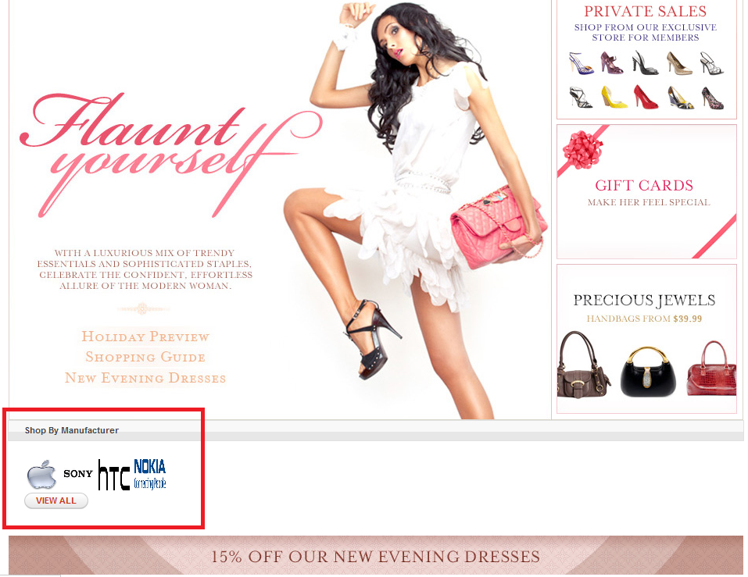

Figure ‑

This is how ‘Shop by Manufacturer’ block will appear on your home page. To go to Manufacturer listing page, click on ‘View All’ button.

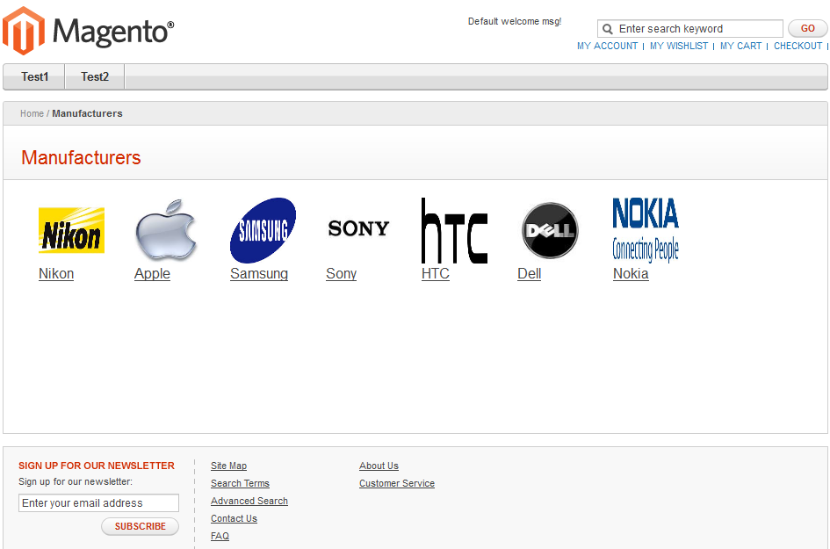

Figure ‑

Click on any brand to navigate to its detail page.

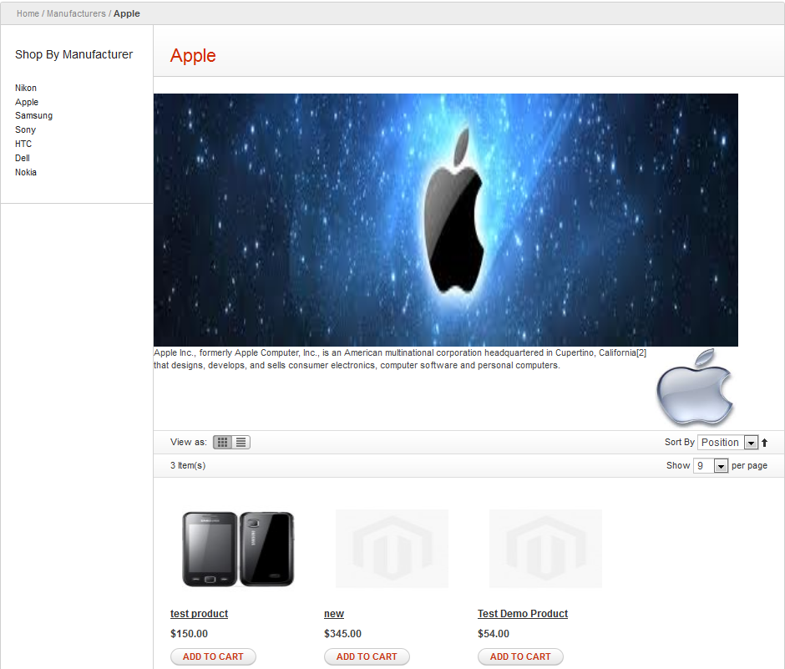

Figure ‑

# Technical Information

**The Shop by Manufacturer module has the following components**

* Controllers: The Shop by Manufacturer Module doesn’t override any core controller functionality.
* Models: The Model contains files to build up collection manufacturers.
* Backend: This module has layout file located in the path:
* app\design\adminhtml\default\default\layout\zeon\manufacturer.xml
* Frontend: This module has some template files located in the path:
* app\design\frontend\base\default\template\zeon\manufacturer
* And Layout file is located in the path:
* app\design\frontend\base\default\layout\zeon\manufacturer.xml
* Database Tables: The Job Manager Module will insert two tables in your data base namely zeon_manufacturer and zeon_manufacturer_store.

# Un-installation

**Below are the steps to un-install the application**

* Remove design files from below folders
  + \app\design\frontend\base\default\template\zeon\ : \app\design\frontend\base\default\layout\zeon\ : remove the layout file job manager
  + \ app\design\adminhtml\default\default\layout\zeon
* Remove Module Activation file
  + Remove “Zeon_Manufacturer.xml” from \app\etc\modules\ folder
* Remove Module from Code
  + Remove files form “app\code\local\Zeon\” of Manufacturer
* Remove Locale file
* Remove “\app\locale\en_US\ Zeon_Manufacturer.csv”
* Remove Database tables [Run below queries in database]
  + DROP TABLE ` **<prefix>**zeon_manufacturer_store`
  + DROP TABLE ` **<prefix>**zeon_manufacturer`
  + DELETE FROM ` `**<prefix>**core_resource` WHEREcore_resource.code = 'zeon_manufacturer_setup'
  + DELETE FROM ``**<prefix>**core_config_data` WHERE `**<prefix>**core_config_data.path LIKE '%`**<prefix>**zeon_manufacturer%

# Unsupported Features & Known Issues

# Troubleshooting